38.66: a) 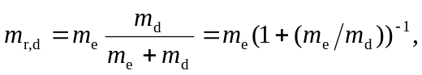 and insertion of the numerical values gives 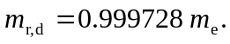 b) Let 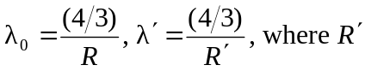 is the Rydberg constant evaluated with 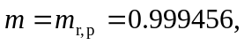 so
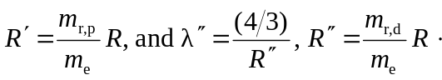
Then
